Tugas Week 2 IS 429 Big data **Christopher Darren - 00000054804**

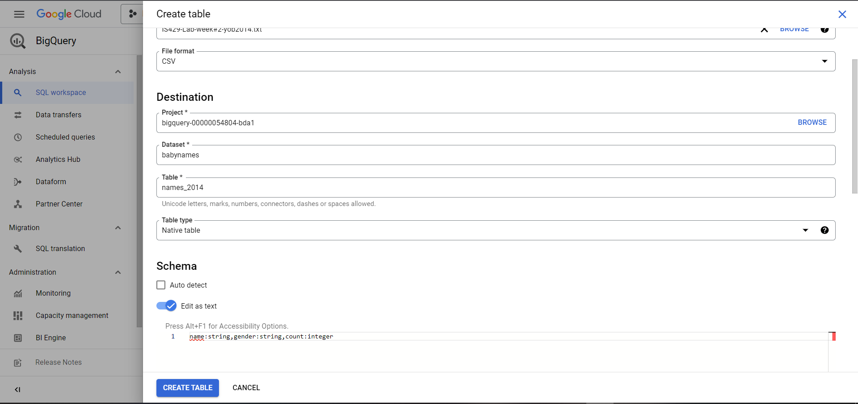

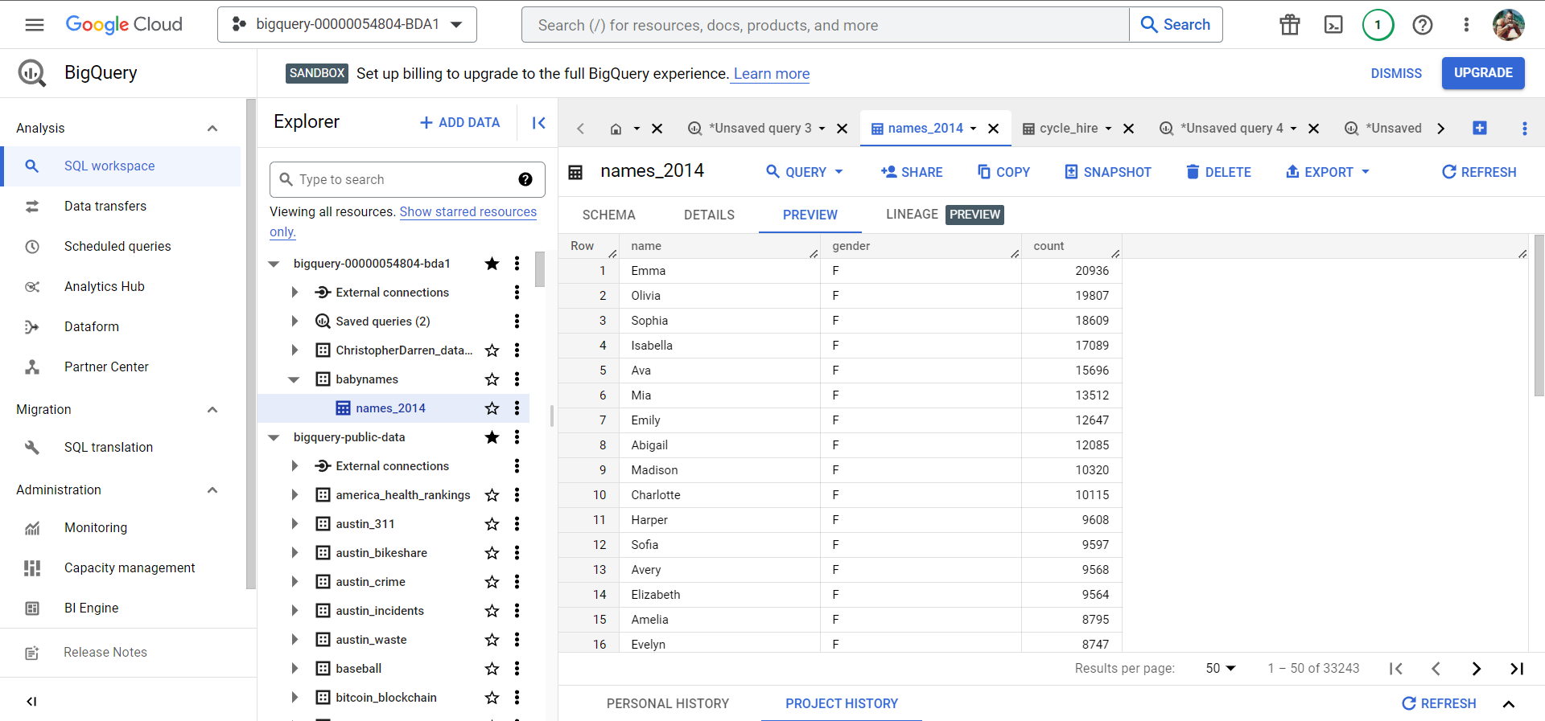

1. **Figure 2.1 Load the data into a new table**

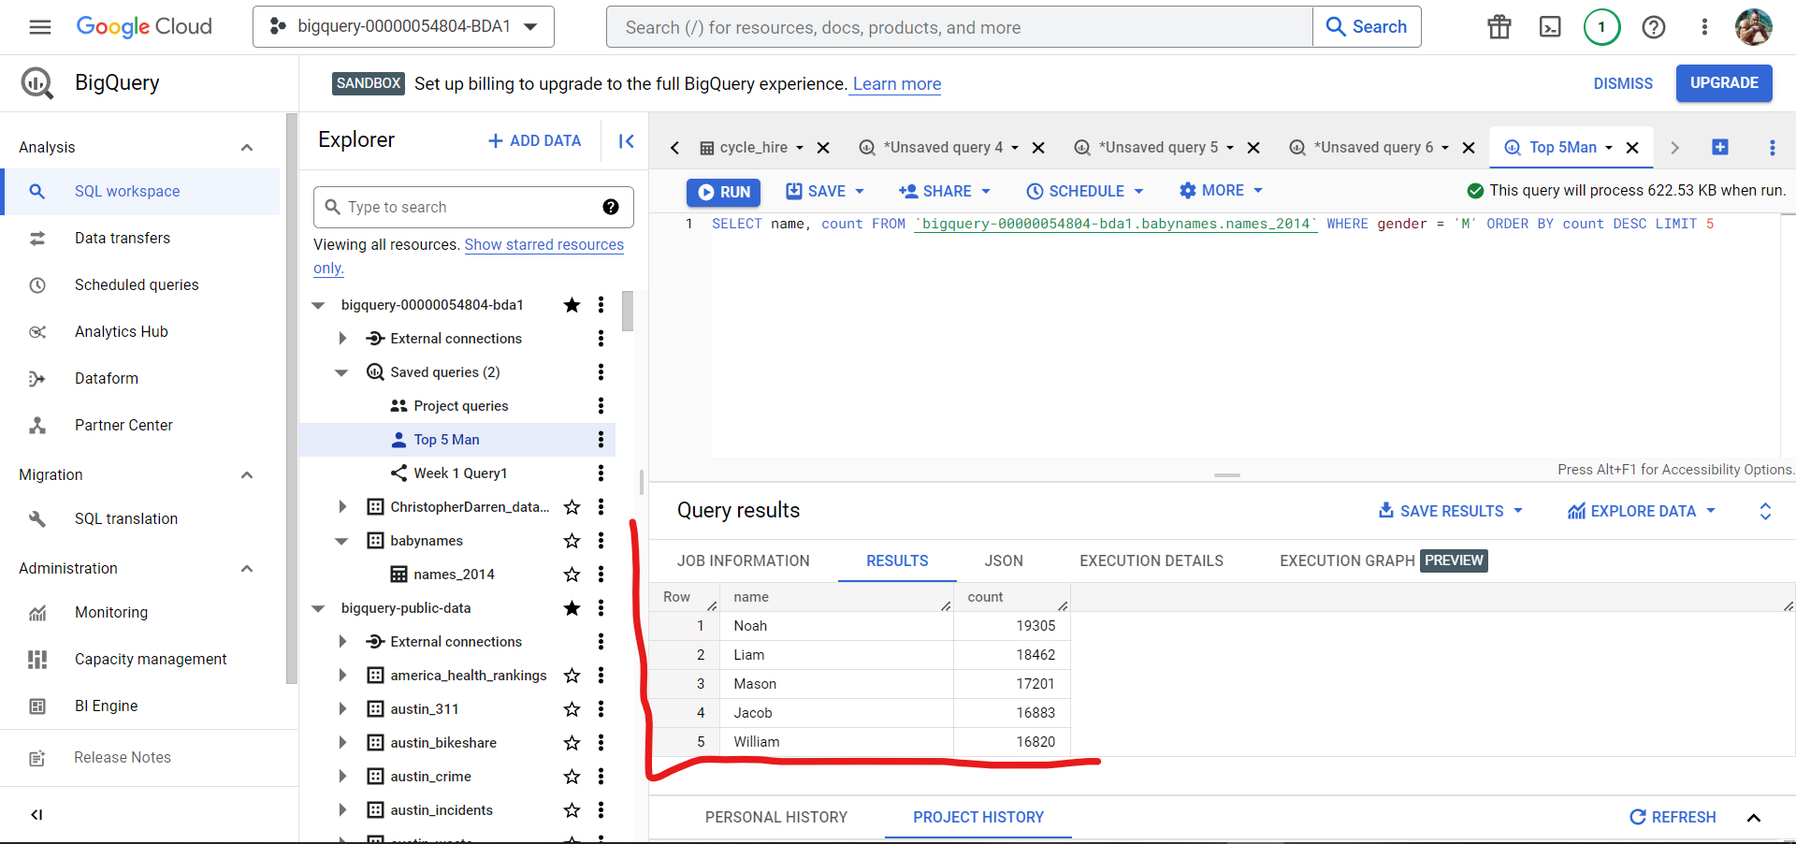

1. **Figure 2.2 Top 5 Man Baby**

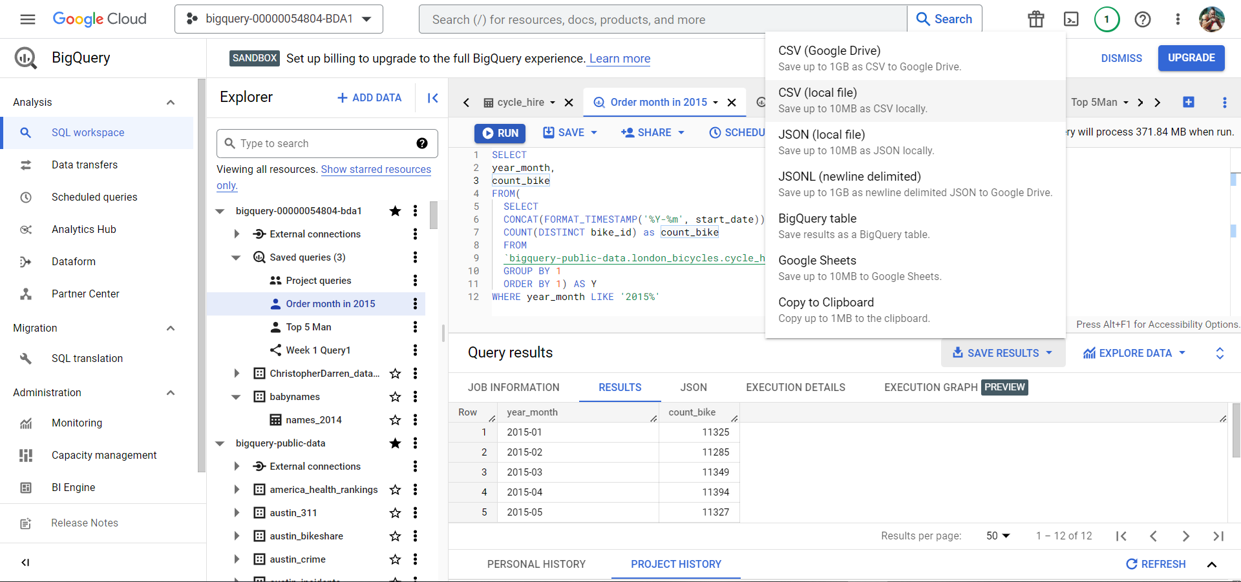

1. **Figure 2.3 Orders by Month in 2015**

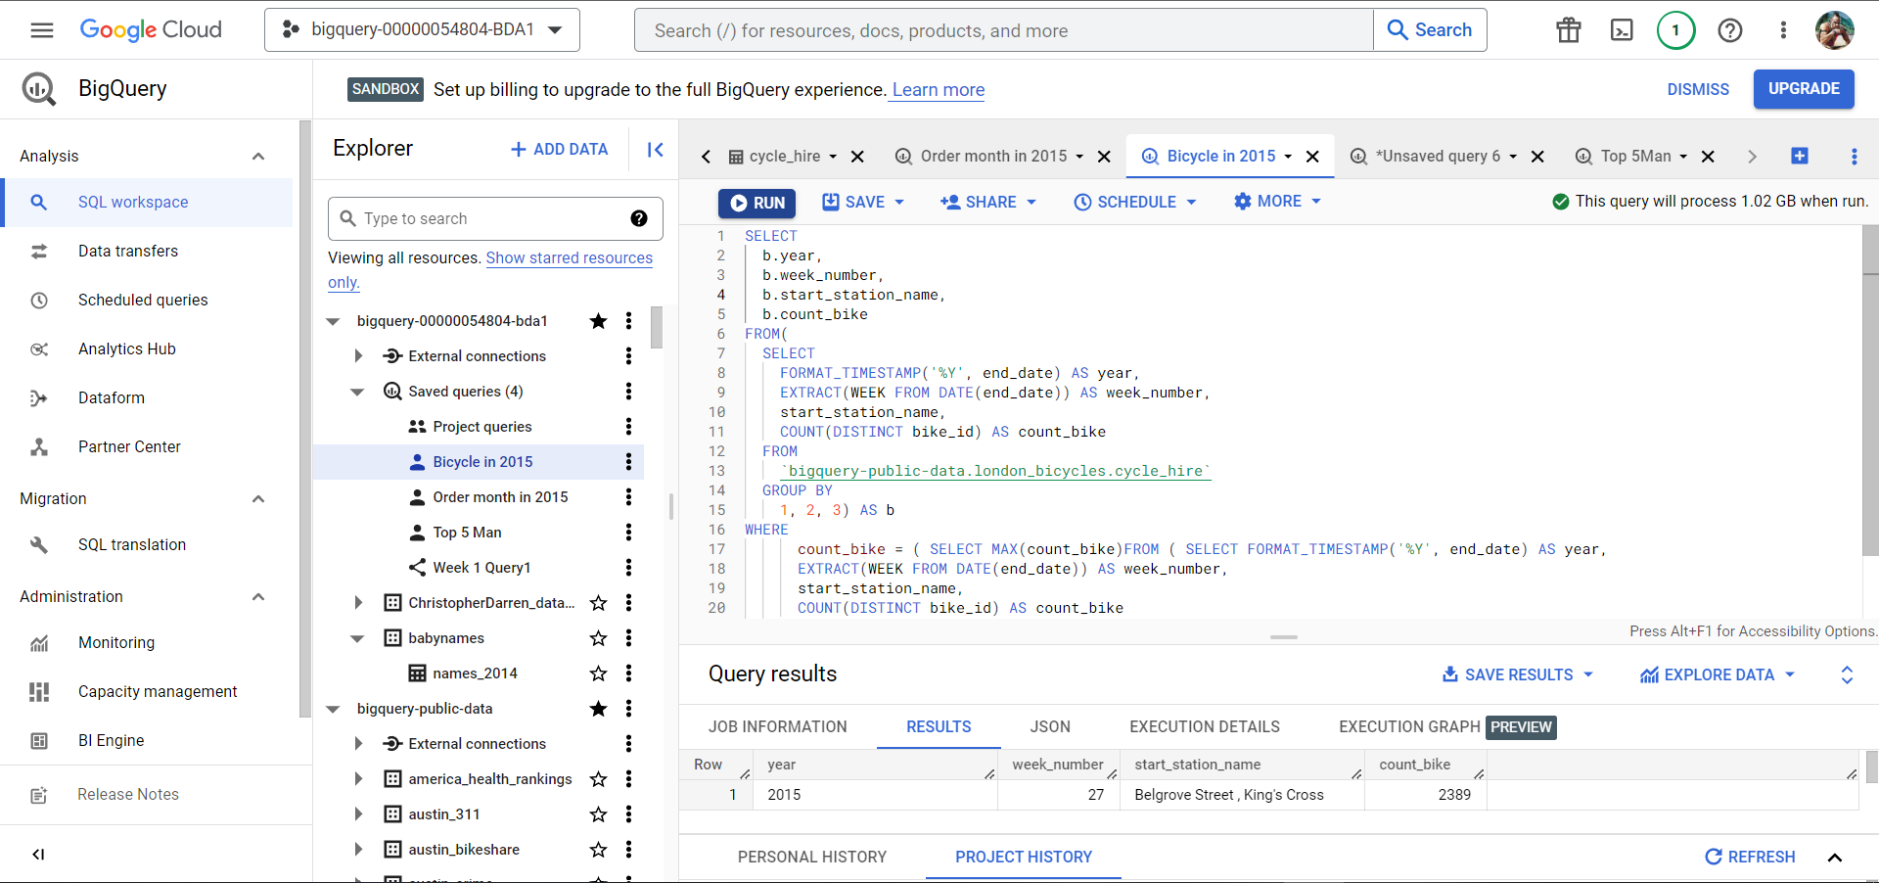

1. **Figure 2.4 On the Week station was installed.**

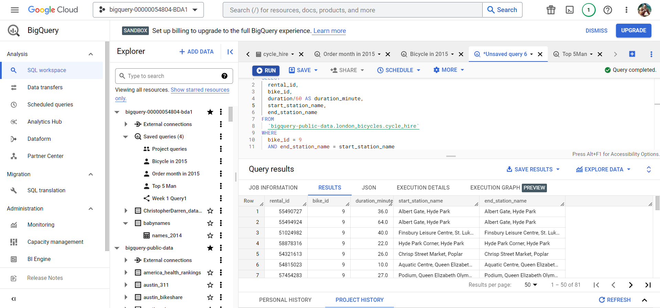

1. **Figure 2.5 End with 9 to start**

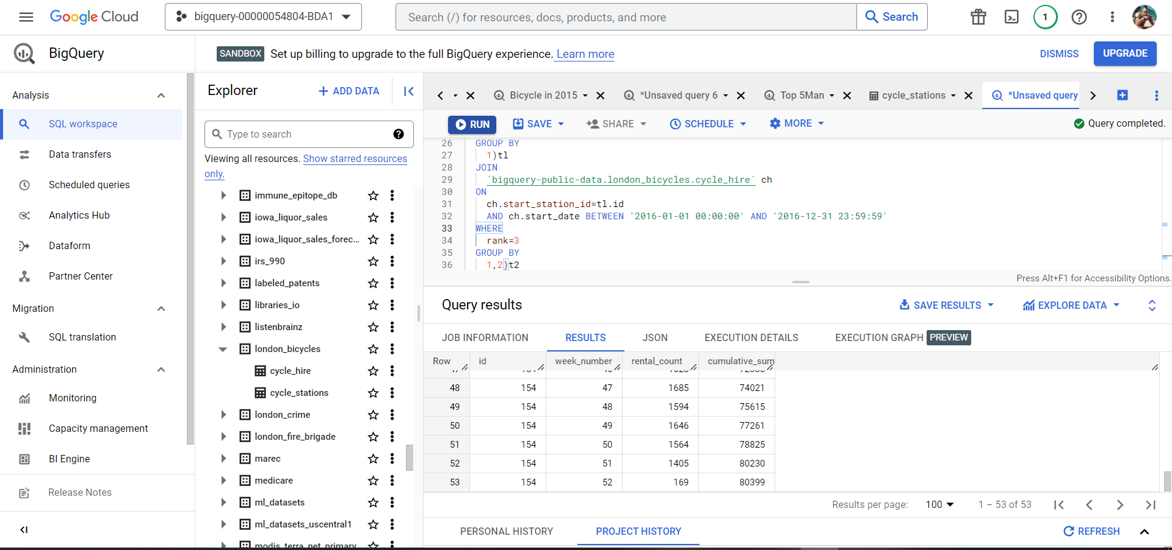

1. **Figure 2.6 3rd busiest Station 2015-2016**

**Link Query  
1.** [**https://console.cloud.google.com/bigquery?sq=1036585851045:81e6d4dbdc4f41528c7a1f4deed20b60**](https://console.cloud.google.com/bigquery?sq=1036585851045:81e6d4dbdc4f41528c7a1f4deed20b60)

**2.** [**https://console.cloud.google.com/bigquery?sq=1036585851045:efe6f3a698914b749a5aaab9817d682e**](https://console.cloud.google.com/bigquery?sq=1036585851045:efe6f3a698914b749a5aaab9817d682e)

**3.** [**https://console.cloud.google.com/bigquery?sq=1036585851045:e973e27746104e799b4a2b442ff58d5e**](https://console.cloud.google.com/bigquery?sq=1036585851045:e973e27746104e799b4a2b442ff58d5e)

**4.** [**https://console.cloud.google.com/bigquery?sq=1036585851045:b8e4819034814088b01cee37e6348564**](https://console.cloud.google.com/bigquery?sq=1036585851045:b8e4819034814088b01cee37e6348564)